EXP NO 24. CREATE A STORAGE SERVICE USING ANY PUBLIC CLOUD SERVICE PROVIDER (AZURE/GCP/AWS) AND CHECK THE PUBLIC ACCESSIBILITY OF THE STORED FILE TO DEMONSTRATE STORAGE AS A SERVICE.
AIM:
To demonstrate infrastructure as a service(iaas) by creating a virtual machine using a public cloud service provider(azure/gcp/aws) configure with minimum cpu,ram and storage and launch the vm
image.
PROCEDURE:
STEP1: CREATE AN ACCOUNT IN MICROSOFT AZURE.
STEP2: GOTO RESOURCE GROUP AND CREATE A RESOURCE GROUP.
STEP3: GIVE NECESSARY THINGS FOR RESOURCE GROUP.
STEP4: CREATE A VIRTUAL NETWORK FOR TO CREATE A VIRTUAL MACHINE.
STEP5: NOW CREATE A VIRTUAL MACHINE WITH UR IP ADDRESS AN USERNAME AND
PASSWORD FOR YOUR VIRTUAL MACINE.
STEP6: AND YOUR VIRTUAL MACHINE IS DEPLOYED.
STEP7: NOW CONNECT THE VIRTUAL MACHINE AND DOWNLOAD THE RDP FILE TO OPEN YOUR
WINDOWS VIRTUAL MACHINE.
STEP8: CREATED A NEW WINDOWS VIRTUAL MACHINE
IMPLEMENTATION:

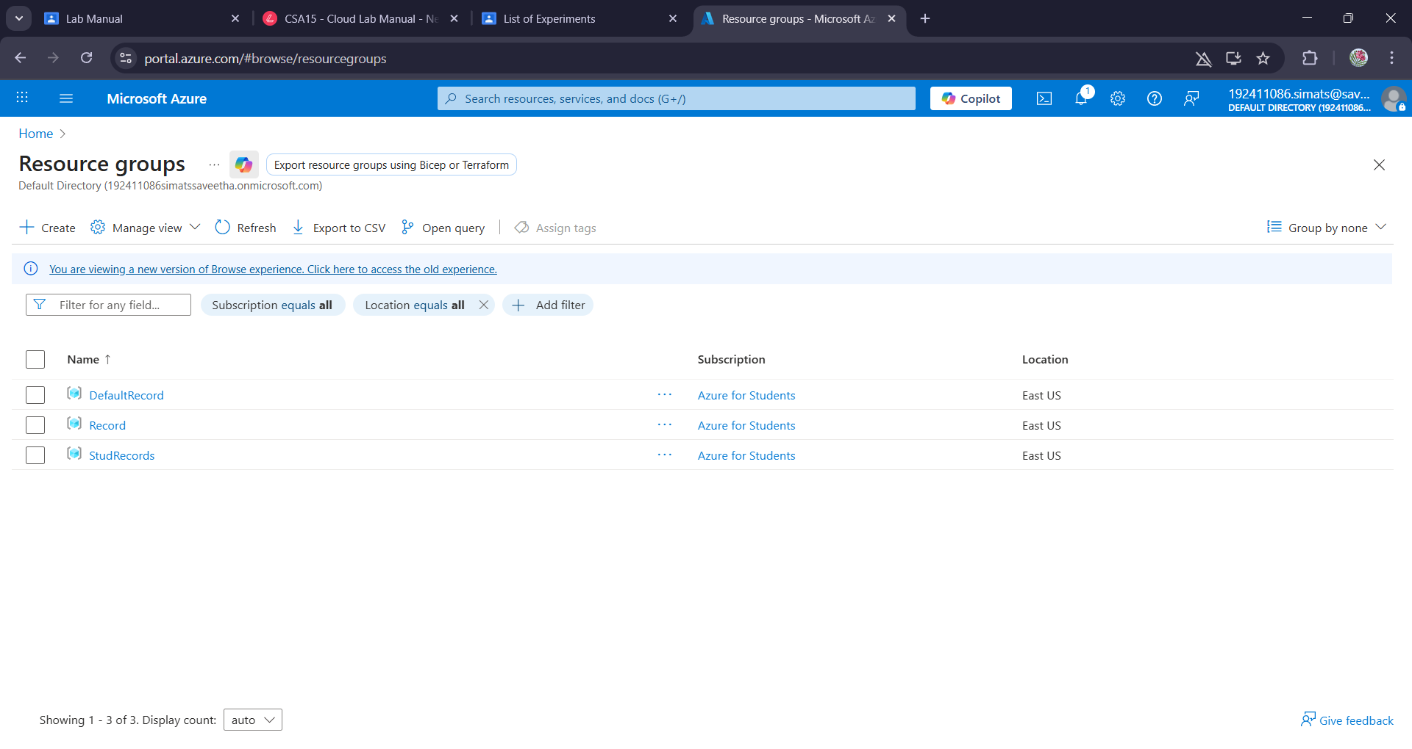

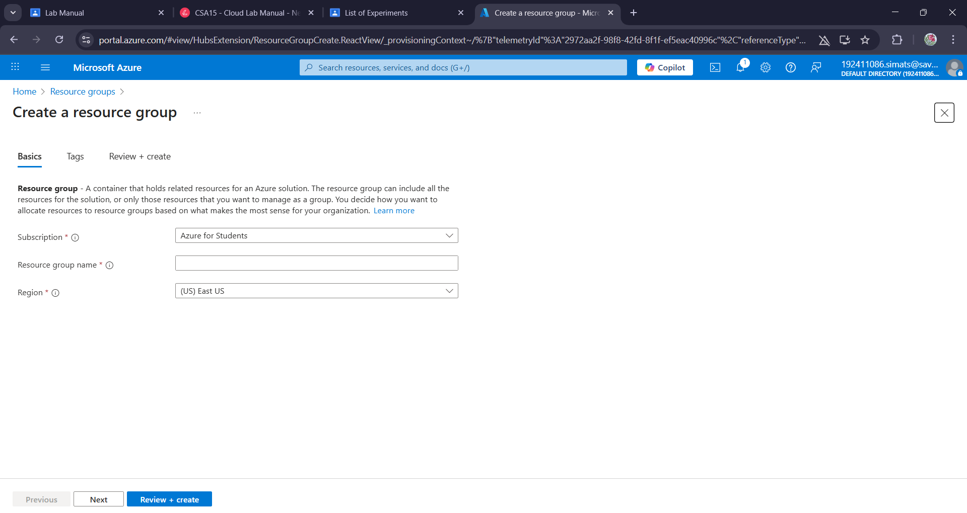

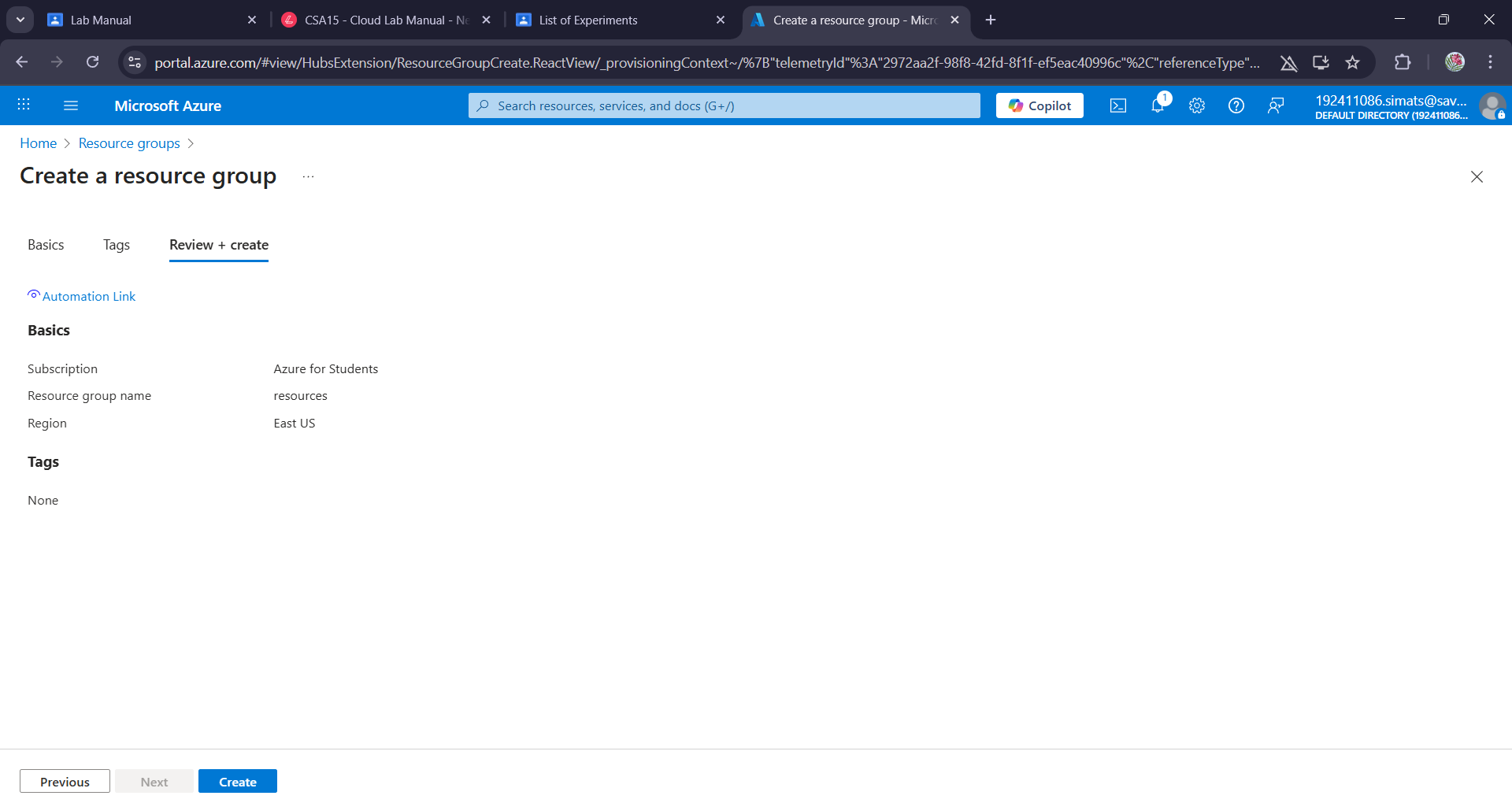

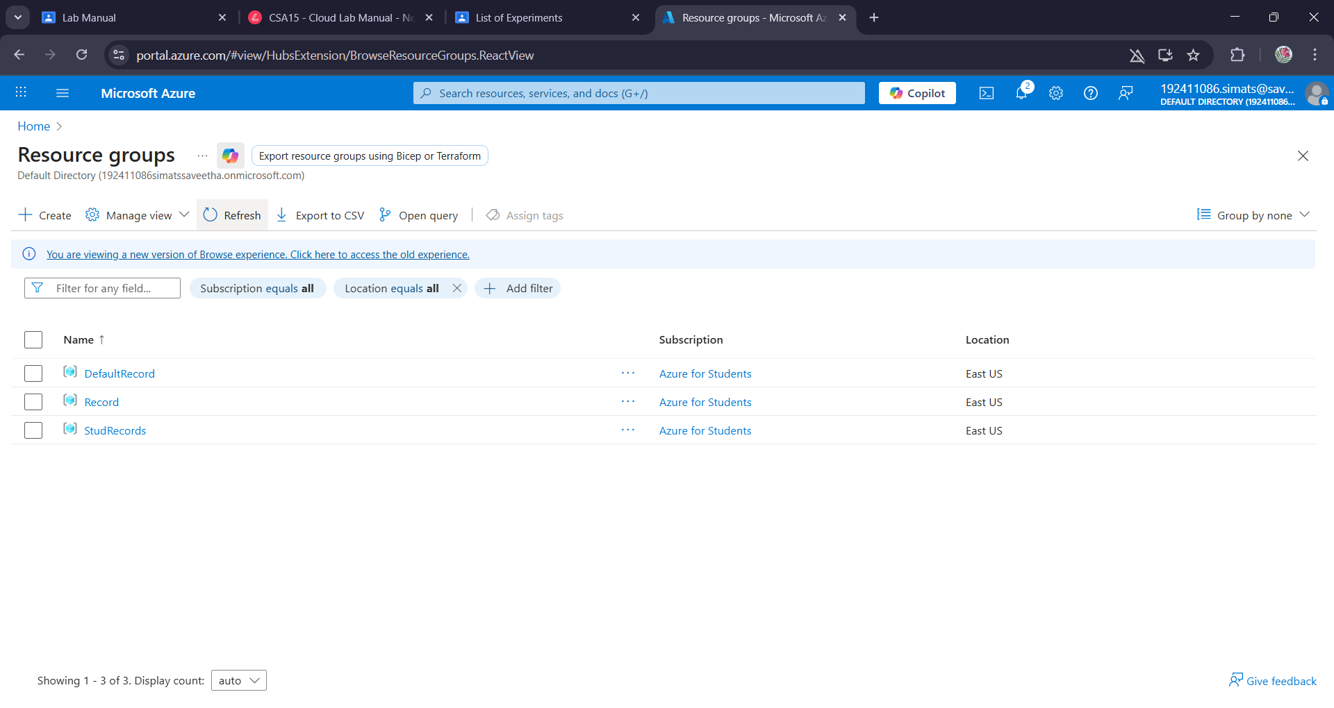

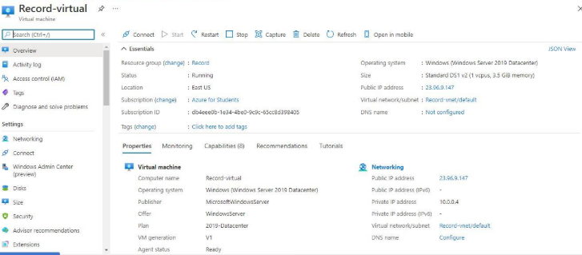

Result:
Infrastructure as a service(iaas) by creating a virtual machine using a public cloud service provider(azure/gcp/aws) configure with minimum cpu,ram and storage and launch the vm
image has been demonstrated.

